**# Understanding Three Stage Architecture of Git:**

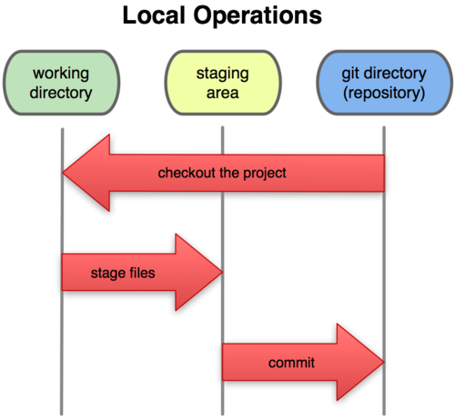

* 1st Stage is the “Working Directory”:

---> The working directory contains the current state of your project files, which are not yet committed to the Git repository.

* 2nd Stage is the “Staging Area”:

---> The staging area contains changes that are about to be committed into the Git repository.

* 3rd Stage is the “Git Repository”:

---> When files get committed to the git repository then they’re in this stage.

_ _ _ _ _ _ _ _ _ _ _ _ _ _ _ _ _ _ _ _ _ _ _ _ _ _

**# References Cited:**

* 3rd Video of CodeWithHarry (Complete Git Tutorials For Beginners In Hindi) Playlist : (Video Name: Git: Three Stage Architecture | Git Tutorials #3):

<https://www.youtube.com/watch?v=Cdg2FGDMglk&list=PLu0W_9lII9agwhy658ZPA0MTStKUJTWPi&index=3>

_ _ _ _ _ _ _ _ _ _ _ _ _ _ _ _ _ _ _ _ _ _ _ _ _ _ _